NEXTAG COMPANY

Medium Saffiano Leather Wallet

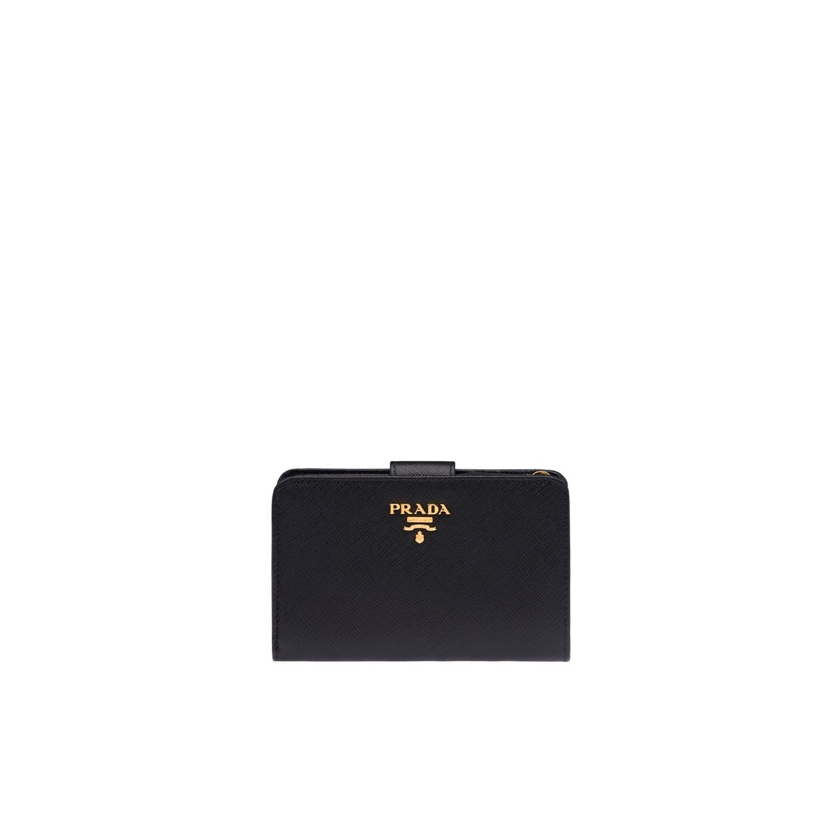

Style # 1MV204_2CDM_F0YQY

650  $

product details

Saffiano leather  
Multicolored Saffiano leather lining  
Gold-toned hardware  
Metal lettering logo  
Snap closure  
Ten credit card slots  
One bill compartment  
One coin compartment with zipper  
9.5 cm height  
14 cm width